

**Exploratory Data Analysis Report**

horizontal line

**INSTITUTE OF ICT PROFESSIONALS (IIPGH), GHANA**

By:

MARJESSNATE

30th of September 2023

TABLE OF CONTENTS

**ACKNOWLEDGEMENTS 4**

**THE PROJECT 5**

**INTRODUCTION 6**

PROFILE OF COMPANY 6

MARJESSNATE 6

Overview: 6

Ownership: 6

Service Offerings: 6

Operational Philosophy: 7

Vision: 7

CLIENT PROFILE 8

OVERVIEW: 8

OWNERSHIP: 9

SERVICE OFFERINGS: 9

DIVISIONS: 9

MEMBER RELATIONSHIP: 9

OPERATIONAL PHILOSOPHY: 10

VISION: 10

**THE SOURCE OF THE DATA 11**

**TOOLS USED 12**

**UNDERSTANDING THE DATA 13**

**DATA RENAMING 14**

**ABOUT THE DATA COLUMNS 15**

**DATA CLEANING 16**

**ANALYSIS 17**

DOB 17

Age 18

Student’s Email Address 18

Location 19

Current module 20

Modules Completed 20

Recommend 21

Satisfaction 21

Preferred Tutor 22

**FINDINGS 23**

**RECOMMENDATION 24**

**CONCLUSION 26**

# 

# 

# 

# ACKNOWLEDGEMENTS

We would like to thank the following for helping us in the creation of this project and the app that comes with it :

* IIPGH: For giving approval the creation of the form sent to students of IIPGH in order to create the dataset and for lending us their Director of Operations, Sir Richard Kafui Amanfu to share information about the association that was crucial in the writing of the client profile
* The students of IIPGH: For taking the time out of their day to fill this form.
* Our tutors: Who were ready to provide support in some parts of the development of this report and the web app that comes with it.

And thanks to the members of Marjessnate:

* Nathan Opata: for handling and generating the data with the help of Miss Barbara.
* Jessica Adzah: for taking charge of the creation of the web app with the help of Sir Edmund.
* Marvellous Isijola: for writing this report and performing the analysis on the dataset with the help of his team and tutors.

# 

# THE PROJECT

The dataset analyzed is data from a group of students from an association which goes by the name Institute of ICT Professionals Ghana (IIPGH).

In this report we are going to look at the data on these students and analyze it in order to make a prototype that creates a way for students to view a profile of their information, achievements and past projects.

The information on these students will be made up to date by the use of a form made by our company. This form will take some input that would otherwise not have been recorded, like their age, location, current module, completed modules and also their feedback on the classes they have had.

# 

# 

# INTRODUCTION

## PROFILE OF COMPANY

### MARJESSNATE

#### Overview:

MARJESSNATE is a company run by 3 IT professionals that provides IT solutions such as data analytics and graphic design. Established in 2023, it aims to be very relevant and frequently thought about in the IT world. Core IT Services is run by three people who are trying to make a mark on the world using IT and taking their company on the journey with them. This report is their first one so far.

#### Ownership:

MARJESSNATE is owned and run by three people who are listed below:

* Marvellous Isijola: (Founder, data analyst, Project manager)
* Jessica Adzah: (Founder, Graphic Designer, Developer)
* Nathan Opata: (Founder)

#### Service Offerings:

* Detailed reports on datasets - Marjessnate looks at the data provided and find trends that show the things that are being done wrong and recommend things that can be done to get a more positive output and also list the findings from the analysis of the dataset.
* Prototype development - Marjessnate then creates a prototype that solves the strain that our client’s business might be going through based on the findings from the data.
* Graphic Design - This is where Marjessnate gives the client a rebrand by doing something like creating a new logo for the client or creating posters they could hand out.

#### Operational Philosophy:

Marjessnate collaborates on datasets supplied by our clients in such a way that more findings can be derived in a shorter period of time.

#### Vision:

To make a name for themselves in the world of IT by supplying their clients with great customer service and treating their client’s data with the care it needs to yield good results.

### 

### 

### 

### 

### 

### 

### 

### 

### 

### CLIENT PROFILE



#### OVERVIEW:

The Institute of ICT Professionals, Ghana (IIPGH) is a professional association made up of experts in various fields of Information and Communication Technology (ICT). The Institute is a connector of ICT professionals from government MDAs (Ministries, Departments and Agencies), educational institutions, corporate organizations, start-ups, investors, and the civil society organizations to create a vibrant ICT ecosystem.

#### OWNERSHIP:

The Institute of ICT Professionals, Ghana is a professional body founded on March 7th 2017.

#### SERVICE OFFERINGS:

As well as having an academy division, the Institute of ICT Professionals collaborates with clients on topics such as:

* ICT Consultancy and Solutions for businesses
* Curriculum review for educational institutions (from basic to tertiary)
* Business Process Outsourcing (Aggregator/Solutions)
* IT Human Resources
* Remote Service Delivery

#### DIVISIONS:

IIPGH is divided into 4 divisions:

* PROFESSIONAL MEMBERSHIP: This division manages the membership of professionals and corporate members of the Institute.
* ACADEMY: This is the training and development division of the Institute.
* PROFESSIONAL SERVICE: This is the consultancy division of the Institute.
* FOUNDATION: Takes care of organizational CSRs (Corporate Social Responsibilities)

#### MEMBER RELATIONSHIP:

Members of IIPGH are eligible for benefits such as recommendations to other companies to convince them to hire the said member and the ability to publish articles if you are in good standing with the association, and to be in good standing you have to pay a yearly fee.

#### OPERATIONAL PHILOSOPHY:

Members of IIPGH follow a code of conduct that determines how they handle their tasks, how they act, and how they represent their association.

#### VISION:

To become the most reliable partner in ICT development in Ghana and beyond

# 

# 

# 

# 

# 

# 

# 

# 

# 

# 

# THE SOURCE OF THE DATA

Using google forms, Marjessnate designed a questionnaire with a clear idea of the mode of operations of the academic division of IIPGH and a thorough understanding of the elements of analyzing student satisfaction through carefully selected questions.

The following is the link that was sent to the students to gather their information and views on the modules and tutors.

*Hello All,*

*We're IIPGH students learning about data analytics, and we've created a special form called the IIPGH Student Info Form. This form is a crucial part of our project, where we're going to study and share the data we collect.We kindly request all IIPGH students to complete it, and we ask the tutors to assist in ensuring that their students fill out the form.*

*We would really appreciate your help in making our project successful. Please take a moment to fill out this form.*

*📝 You can access the form here:*

[*https://bit.ly/IIPGH-SF*](https://bit.ly/IIPGH-SF)

*Thank you so much for your support.*

*Best regards,*

*IIPGH Students in the Data Analytics Module*

The data used in the analysis were the responses of students of IIPGH using the Google forms survey.

# 

# TOOLS USED

The tools used in this analysis are stated below:

* **Google Colab:** This is the software we used to write the code that gives us the graphs, numbers, and percentages referenced in this report.
* **Google Docs**: This is the software we used to create this report.
* **Google Forms:** This is the software we used to create the form that created the dataset.
* **Google Slides:** This is the software we used to create the presentation.
* **Google Sheets:** This is the software we used to edit and view the dataset.

# 

# 

# 

# 

# 

# 

# 

# 

# UNDERSTANDING THE DATA

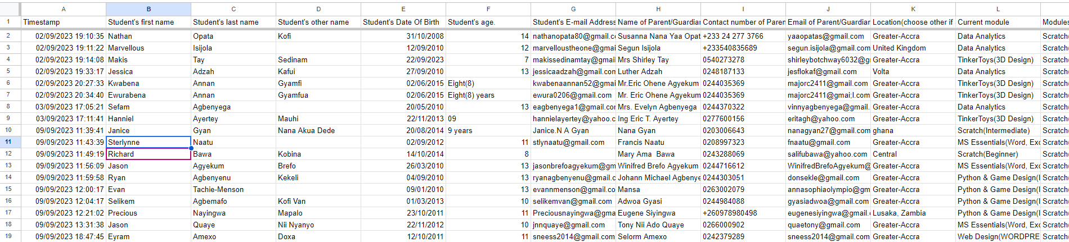

A total of 70 students have filled the form that was sent out. The answers were required for questions such as the student’s names, DOB, age, and information such as their email addresses, their parent’s email addresses and location, their completed modules and current module were also recorded. A percentage of this information won’t be of use to the analysis but can be useful in the development of the web app, and the loading in of information to the web app. The columns left out of this analysis include:

* First Name
* Timestamp
* Last Name
* Other Name
* Name of Parent/Guardian
* Contact Number of Parent/Guardian
* Email of Parent/Guardian

# DATA RENAMING

To make the analysis more straightforward and understandable, some of the columns have been renamed. For a detailed look at the renamed columns, check out the table below. Note that only the columns useful to this analysis were renamed.

| **QUESTIONS** | **NEW NAME** |
| --- | --- |
| Student's Date Of Birth | DOB |
| Student’s age | Age |
| Location(choose other if abroad and state country) | Location |
| Would You Recommend the IIPGH Coding Program to others? | Recommend |
| How Satisfied Are You With The Lessons Learnt so Far? | Satisfaction |
| Which Tutor(s) Did You Enjoy Being In Their Class? | Preferred_Tutor |

# ABOUT THE DATA COLUMNS

Under this heading, the columns used in the analysis are going to be talked about, their information is below.

**DOB:** This column contains the Date Of Birth of the students who filled the form.

**Age:** This column contains the age of the students at the time of their filling the form

**Location:** This column contains the location of the students at the time of their filling the form.

**Student’s Email Address:** This column contains the email addresses of the students that filled the form.

**Current Module:** This column contains the current module of the student at the time of their filling the form.

**Modules Completed:** This column contains the modules students have completed at the time of their filling the form.

**Recommend:** This column holds the answer to whether or not a student would recommend IIPGH to other people being yes or no.

**Satisfaction:** This column holds the answer to whether or not a student is satisfied with their experiences at IIPGH.

**Preferred_Tutor:** This column contains the names of Tutors that students prefer.

# DATA CLEANING

**DOB:** The first few entries were scrutinized in order to confirm their authenticity.

**Age:** 11 entries in the Age column were text based so they were changed to integers as the Age column is a numeric column. The first 12 entries were also scrutinized in order to confirm that the right age and date of birth were imputed. The process was halted as it would have left Marjessnate with little time to complete the report.

**Location:** 1 person chose to write ghana and not pick an exact location so it was manually changed to Greater-Accra.

# ANALYSIS

In the analysis we are going to be talking about each column and giving a summary of what we found from them. The columns that will be talked about are only the columns related to the analysis.

## DOB

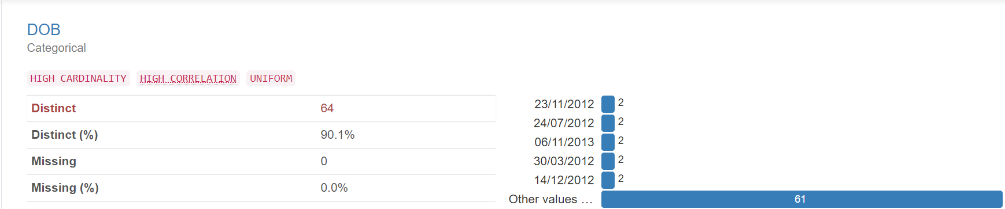

There are 7 instances of dates being mentioned twice. Most of the dates of birth were unique with some occurring twice in the sheet.

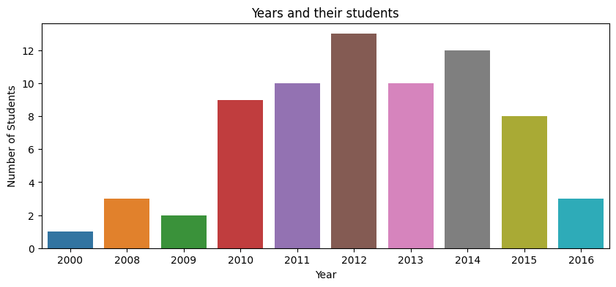2012 is the most common Birth Year as according to our analysis, over 12 students are born in that year alone.

## Age

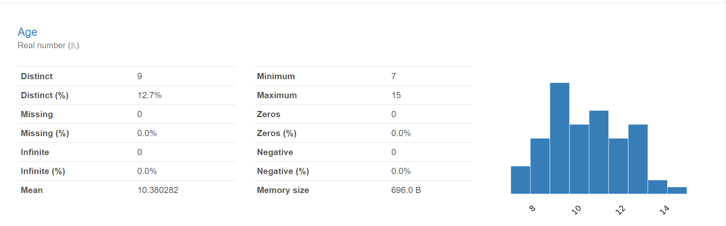

The ages of students did not exceed 15 years old and did not go below 7 years old. There is not a missing row as the age was required to be filled in the form and the mean age of people 10.41.

## Student’s Email Address

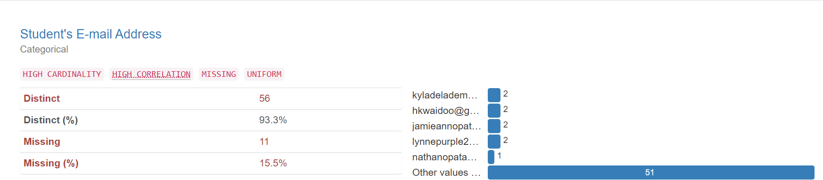

11 out of the 71 or 15.49% of students who filled out the form did not have an email address, some email addresses were mentioned twice in the dataset.

## Location

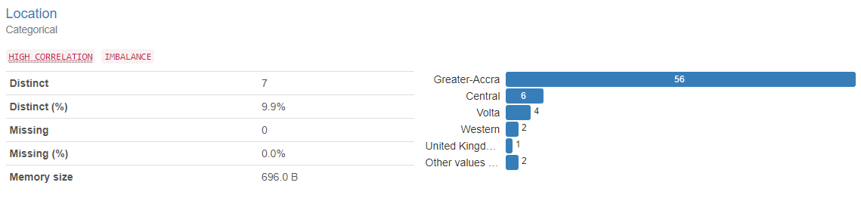

The location column showed the location of the students who filled the form. Every student who filled the form stated their location as the missing value is 0 or 0.0%.

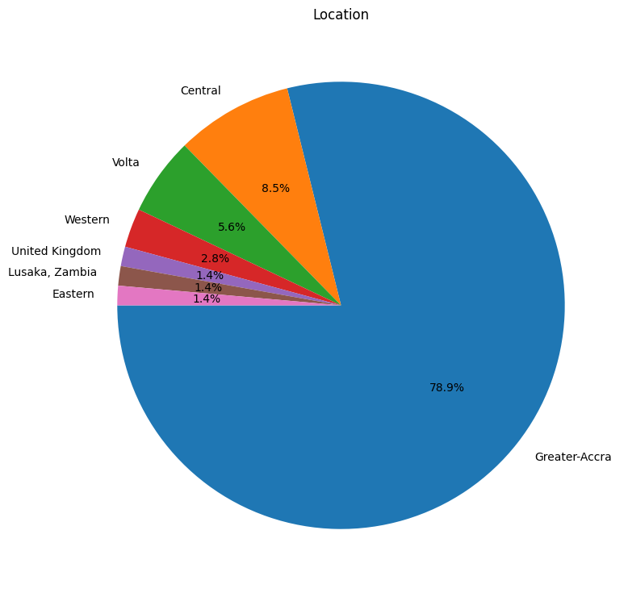

Most of the students are located in Greater Accra as the value of the students in Greater Accra, that is, 78.9% of the students. The second highest populated area is the Central Region with a percentage of 8.5 students in that location.Eastern Region, Zambia and the United Kingdom have only one student each.

## Current module

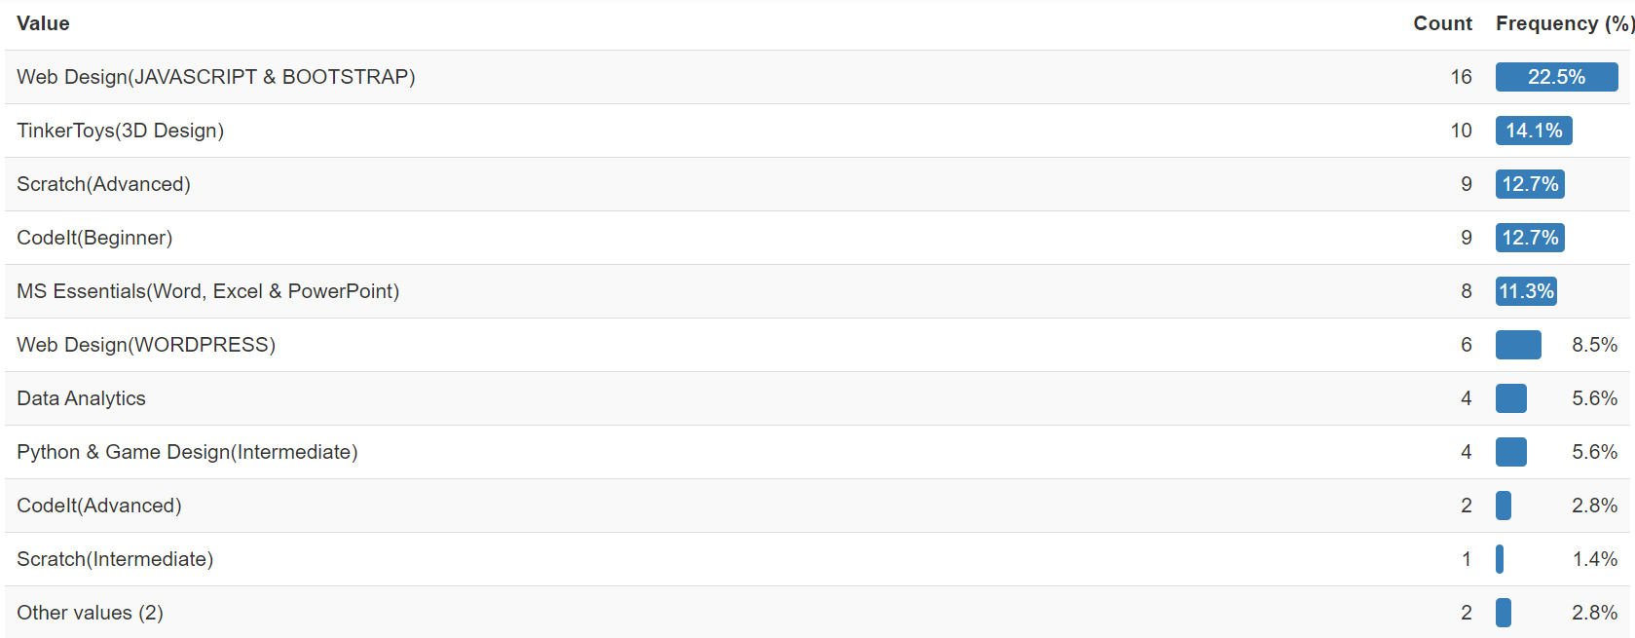

Web Design(JAVASCRIPT AND BOOTSTRAP) is the most common current module of the dataset with 16 or 22.5% of the students who filled the form in the said module. Scratch(Intermediate) is the least common current module of the dataset with only 1 or 1.4% of the students in said module.

## Modules Completed

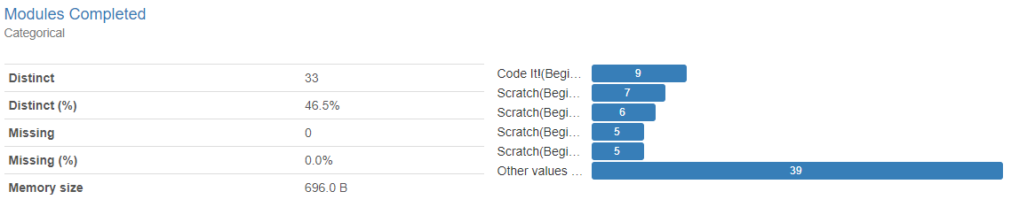

This column represents the modules completed or finished by students who filled the form. There were 33 distinct entries. All students filled this column since there are no missing values.

## Recommend

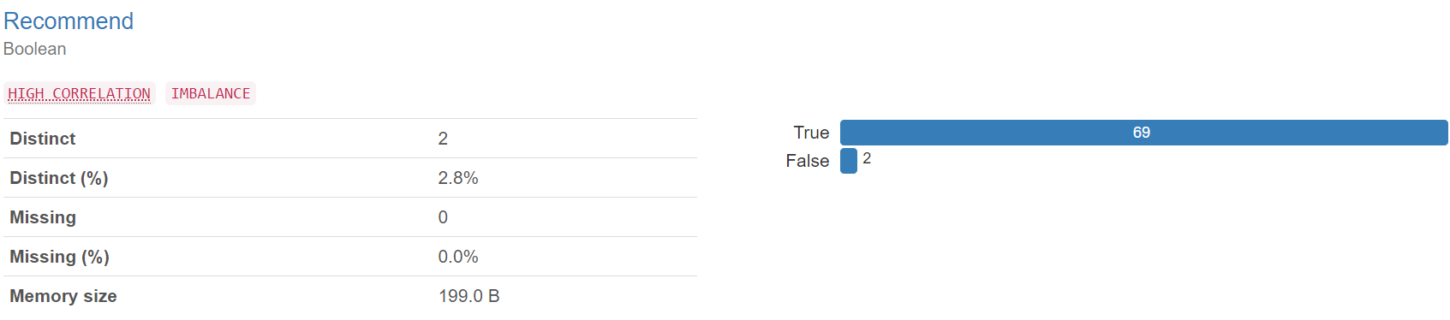

Out of the 71 people who filled the form, 69(97.18%) people recorded that they would recommend IIPGH to other people while the other 2(2.81%) people said otherwise.

## Satisfaction

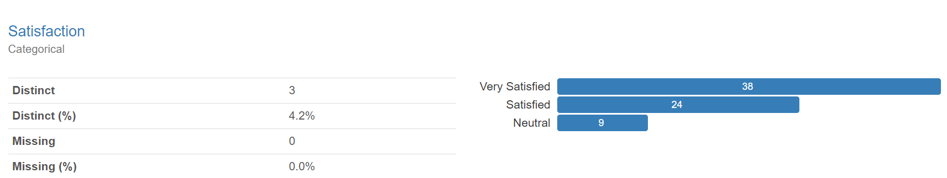

38(53.52%) people were very satisfied with their experiences at IIPGH, 24(33.8%) people were not exceedingly satisfied with their experiences so far, while the remaining 9(12.67%) people preferred not to say and recorded their answer as neutral.

## Preferred Tutor

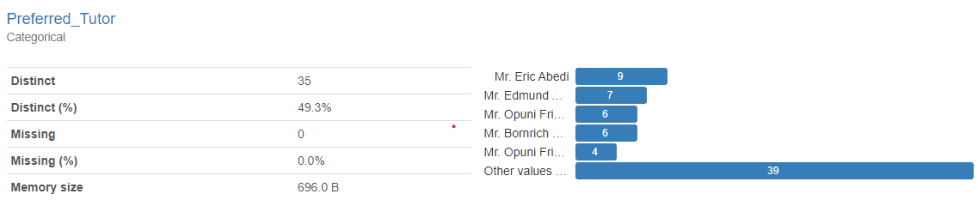

This column represents the tutors or teachers preferred by the students who filled the form. There were 35 distinct entries. All students filled this column since the missing value of this column is 0 or 0.0 %.

# FINDINGS

* The years between 2010 and 2015 had the most students born in them.
* The students who filled out the form were between the ages of 7 and 15
* 15.49% of the students who filled out the form did not have emails.
* Greater Accra had the most students living there with 78.9% of the students recorded in the spreadsheet living there, and the United Kingdom, Zambia and the Eastern Region of Ghana had the least amount of students living there with 1.4% of the students recorded each.
* WEB DESIGN(JAVASCRIPT AND BOOTSTRAP) was being done by more students with 22.5% of them doing this course while Scratch(Intermediate) was the least common module among students with only 1.4% doing the module.
* 97.18% of the people who filled out the form recorded that they would recommend IIPGH to other people, but the other 2.81% said otherwise.
* 53.52% of students were very satisfied with their experiences so far at IIPGH, 33.38% were not as exceedingly satisfied with their experiences so far, but 12.67% did not have anything to say and remained neutral.
* Students when filling the form thought that scratch, code it, and app inventor needed improvement.
* Some recommendations that students had was to implement modules like Robotics, Artificial Intelligence, Animation and Graphics Design.
* Students recorded that they had challenges with Code It and Network Fluctuation.

# 

# 

# 

# 

# 

# RECOMMENDATION

According to the analysis done on the data from the form, Marjessnate has found that IIPGH’s students are concentrated at one location being Greater-Accra, Marjessnate would advise that they make more reach out to less IIPGH populated areas in order to introduce more children to IT.

Marjessnate would also recommend that they push to recruit more young students as they tend to spend more time at IIPGH because older children tend to leave IIPGH in order to further their education or to fully focus on their examinations but younger children typically have less responsibility and can focus on their classes so the actually stay longer.

97.18% of students said that they would recommend IIPGH to other people, this shows that IIPGH is doing a lot of things well, so in order to maintain this opinion from people, IIPGH should try to maintain their standards, but not invalidate the other 2.81% who said otherwise.

IIPGH should also take note of their student’s experiences as some students recorded that they had challenges/difficulties during their time at IIPGH.

The following are some other recommendations:

Workload Management: Many students mentioned that workload management is a challenge. To address this, consider providing clearer guidelines and deadlines for assignments, and ensure that the workload aligns with the students' availability.

Project Alignment: Some students mentioned that projects should align better with what they've learned in past modules. Make sure that the projects and assignments are designed to reinforce the concepts covered in the modules.

Additional Modules: Several students expressed interest in new modules or courses. Consider expanding your course offerings to include topics like animation, software programming, robotics, AI, and more. This can attract a broader range of students and keep them engaged.

Tutor Feedback: Pay attention to the feedback regarding tutors. Students mentioned enjoying specific tutors, so consider the qualities and teaching methods of these tutors and try to replicate those qualities in other instructors.

Satisfaction Levels: Most students reported being satisfied with the program, which is a positive sign. Continue to maintain the quality of teaching and support that leads to high satisfaction levels.

Challenges: Pay attention to the challenges students mentioned, such as access muting during online sessions. Addressing these technical issues can improve the overall learning experience.

Content Enhancement: Some students mentioned that they wanted more encouragement or that certain content areas needed improvement. Use this feedback to enhance the quality of your teaching and support.

Feedback Loop: Establish a feedback loop with students where they can regularly provide input on the program's content, tutors, and overall experience. This can help you continuously improve.

Time Management: Help students with time management strategies to better handle their coursework alongside other responsibilities like school.

Individualized Support: Provide individualized support to students who may be struggling with certain aspects of the program or modules.

Monitoring Progress: Implement systems to track student progress and ensure that they are advancing through the modules at an appropriate pace.

And lastly Marjessnate would recommend that IIPGH creates a web app designed specifically for students. This web app should contain:

* A Home page that can show some of the news concerning IIPGH’s Academy Division.
* An About Us page that describes the reason for which another website has been created under IIPGH’s name and the function of the website.
* A page containing icons with information on IIPGH students
* A page that contains the projects of IIPGH students

# 

# CONCLUSION

The data analyzed in this report was sourced from a form sent to students in order to get all the information needed for the analysis and the creation of the prototype.

Google tools such as Google Slides, Google Colab, and Google Docs were used in the creation of the report and the presentation. And in the analysis, some columns were left out as a result of them not being useful to the analysis, but out of some of those columns general findings could be derived.

Some columns were renamed to make them more legible and easier to work with. There were also some issues with the responses so data cleaning had to be initiated.

The analysis consisted of running the data through xplore and noting down what was evident from the graphs it plotted and the findings it derived, in some cases Marjessnate plotted their own graphs using pandas, seaborn and matplotlib.

Some findings derived from the analysis are that:

* The students who filled out the form were between the ages of 7 and 15
* 15.49% of the students who filled out the form did not have emails.
* Greater Accra has the most students living there.
* 97.18% of students said they would recommend IIPGH to other people.

And some things we recommended they do were to:

* Reach out to younger students.
* Take note of their student’s experiences.
* Reach out to regions with less IIPGH students.
* Monitor satisfaction levels
* Consider adding more modules

Slide 1: Title Slide

Title: Exploratory Data Analysis Report

Subtitle: Institute of ICT Professionals (IIPGH), Ghana

Your Name (Marjessnate)

Date

Slide 2: Acknowledgments

Title: Acknowledgments

List of individuals and organizations you want to thank for their contributions to the project.

Slide 3: Introduction

Title: Introduction

Briefly introduce the project and its objectives.

Mention the purpose of the analysis and its relevance.

Slide 4: Profile of Marjessnate

Title: Profile of Marjessnate

Briefly introduce your company, including its founders, services, and mission.

Mention the year of establishment.

Slide 5: Profile of IIPGH

Title: Profile of IIPGH

Provide an overview of the Institute of ICT Professionals, Ghana, including its mission, divisions, and services.

Mention the year of foundation.

Slide 6: Data Source

Title: Data Source

Explain how you collected the data, mentioning the use of Google Forms.

Include a brief message or link to the form used for data collection.

Slide 7: Tools Used

Title: Tools Used

List and briefly explain the Google tools and software you used for data analysis and reporting (e.g., Google Colab, Google Docs, Google Sheets).

Slide 8: Understanding the Data

Title: Understanding the Data

Discuss the nature of the dataset, the number of respondents, and the columns included.

Mention that some columns were renamed for clarity.

Slide 9: Data Cleaning

Title: Data Cleaning

Explain the steps you took to clean the data.

Highlight any specific issues you encountered and resolved during data cleaning.

Slides 10-17: Analysis

Title each slide according to the columns you analyzed (e.g., "DOB Analysis," "Age Analysis," "Location Analysis").

Present key findings, statistics, and visualizations related to each column.

Use graphs, charts, and tables to illustrate your points.

Slide 18: Findings Summary

Title: Findings Summary

Provide a brief summary of the main findings from your analysis.

Highlight the most important insights.

Slide 19: Recommendations

Title: Recommendations

Present your recommendations based on the analysis.

Use bullet points to list specific actions or strategies suggested for IIPGH.

Slide 20: Conclusion

Title: Conclusion

Summarize the main points of your report.

Emphasize the significance of your findings for IIPGH.

Slide 21: Thank You

Title: Thank You

Express your gratitude to the audience for their attention.

Invite questions or comments from the audience.

Slide 22: Contact Information

Title: Contact Information

Provide contact details for Marjessnate or any relevant contact information.

Slide 23: Q&A

Title: Q&A

Open the floor for questions and answers from the audience.

Slide 24: Additional Recommendations

Title: Additional Recommendations

Include any additional recommendations or future directions for the project.

Slide 25: References

Title: References

List any references, sources, or citations used in your analysis.

Slide 26: Closing Remarks

Title: Closing Remarks

Conclude the presentation with any final thoughts or remarks.